**Vertebrate Notes**

**What limited the size of invertebrates?**

Feeding: Lack of jaws limited size of food and therefore amount of calories obtained with each feeding

Obtaining Oxygen: small structures limited amount of oxygen obtainable, limits energy from cellular respiration

Body Support: lack of strong, internal support limited size

Locomotion: Related to lack of internal support; limits muscle attachment and agility and movement

Response to Stimuli: simple sense organs + simple brains limit reactions + sensing

**What is a Chordate?**

What are five unique characteristics of chordates? [Video](https://www.shapeoflife.org/video/chordates-we%E2%80%99re-all-family)

| 1 **Pharyngeal Gill slits** |
| --- |
| 2 **Post - anal tail** |
| 3 **Notochord** |
| 4 **Dorsal hollow nerve cord** |
| 5 **Segmented muscles** |

Label the features on the lancelet diagram: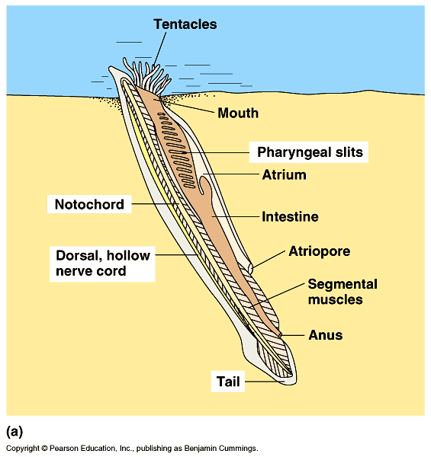



**Notochord**: flexible rod of tissue that extends the length of the chordate

body; supports nerve chord

**Dorsal hollow nerve cord**: develops into

the brain and spinal cord

**Pharyngeal gill slits:** in throat area, become gills jaws etc

**Tail:**

**Development links echinoderms to invertebrate chordates to vertebrates!**

Egg + Sperm → zygote (one cell) which through cell division becomes a ball of cells (blastula phase of embryo). These cells then differentiate into cell layers (gastrulation), then into early embryonic phases.

Deuterostomes like echinoderms and chordates, start the early phases in the same manner- non-spiral cleavage, mesoderm bulges out of coelom, anus develops from blastopore.

Chordates, both vertebrate and invertebrate ones, share 5 features during embryonic development. After the early phases, the groups differentiate.

**Comparing Vertebrate Chordates and Invertebrate Chordates**

* **All Chordates share the following features:**
  + Examples include lancelets, tunicates, salps, fish, amphibians, reptiles, birds, mammals

| 1. |
| --- |
| 2 |
| 3 |
| 4 |
| 5 |

* + **All Vertebrate, chordates share the following features in addition to those listed above:**
    - Examples include fish, amphibians, reptiles, birds, mammals

| 1. skull: protects brain |
| --- |
| 2. backbone of vertebrae: protect nerve cord |
| 3. appendicular skeleton - 2 pairs of limbs |
| 4. most have a hinged jaw |
| 5. ribs protect heart |

**Reproduction in Fishes**

* **Oviparous:**
* **Ovoviviparous:**
* **Viviparous or Aplacental viviparity:**

**Tetrapods**

* **All tetrapods, which are vertebrate chordates, have**

1. Reptiles, frogs, four limbs, air breathing and Terrestrial

Examples include Frogs, Reptiles, Mammals, Snakes, but not FISH

**Amniotes**

* **All amniotes, which are tetrapods and vertebrate chordates, share the following features**

| 1. Amniotic egg: waterproof with a shell |
| --- |
| 2. External fertilization - sperm deposited into female no need for watery habitat |
| 3. Water tight skin, skin contains keratin that prevents dehydration, Scales and Keratin, hair nails and horns are made of Keratin. |

Examples include Birds, Reptiles, Mammals, but not fish or amphibians.

**Regulation in the Vertebrates**

| Ectotherm: source of body heat is external | Endotherm: source of body heat is internal |
| --- | --- |
| Poikilotherm: body temperature varies | Homeotherm: maintain constant body temp |

* The endothermic amniotes are the ________ & _______________